**Names: Niyonsenga Felicien**

**Reg Number: 22rp07505**

**Assignment install window server and configuration**

Steps used:

Step1: create name of server and choose its vervion.

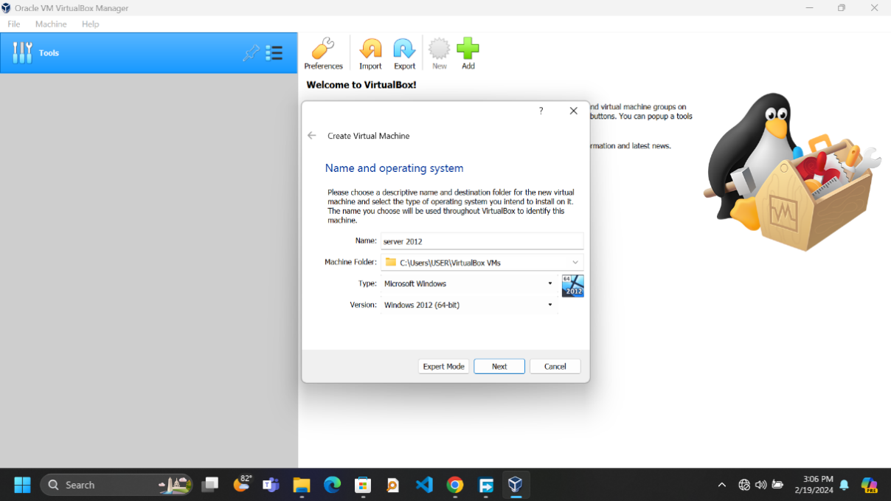

Step2: choose size of RAM

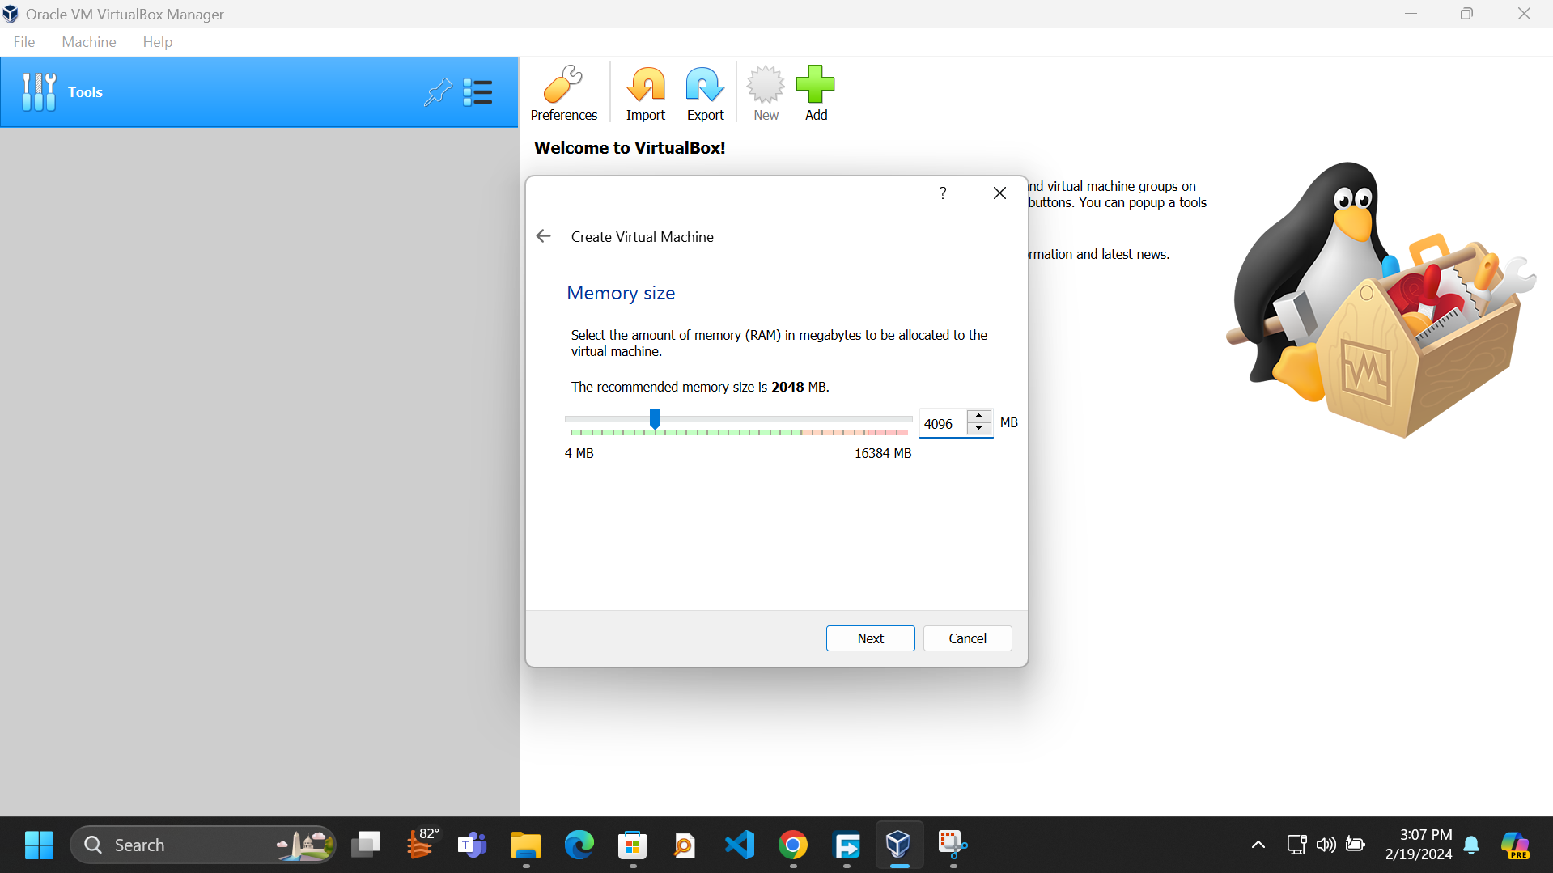

Step3: Choose size of HDD

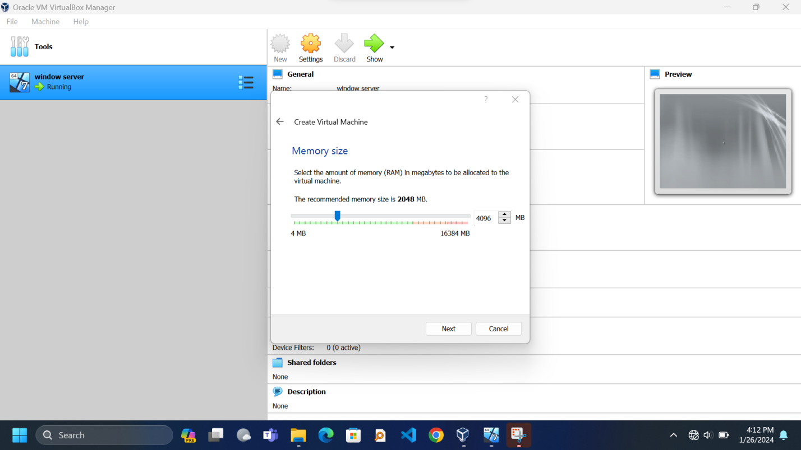

Step4:

